City development report

City management is a complex topic that can directly affect millions of people. There are multiple key factors such as, service delivery, power supply and waste management. Regulation decisions such as laws to implement are also key to managing a healthy city. The goal of a city is to make the lives of the citizens living in the city’s lives better, so citizen satisfaction is a key factor in city management. A city should develop over time, increasing its population and capacity such as number of buildings. The infrastructure must also be maintained, degrading buildings and roads should be repaired. Planning this

Basic requirements of types of buildings include schools for citizens to learn. Residential buildings for citizens to stay at. Work buildings where citizens can earn money. All these buildings are key to the city’s life. The city economy is what dictates the life of the citizens in the city. The city needs to earn money to pay for the service delivery and general costs of running a city. The city earns money through tax which will need to be in a fine balance between citizen satisfaction and city expenses. A city can be broken down into smaller parts or districts. This helps with managing the city. A city Is managed by a Government. The Government is responsible for everything in the city and will be in charge of setting tax levels, spending resources, implementing policies.

The city will develop over time, and it should get better overtime, incentivizing people to move to the city. The city grown will need to be planned as this will encourage an urban first-class city. Strategic Urban Planning focuses on setting high-level goals and determining desired areas of growth for a city or metropolitan area. A city should keep the environment in mind, and this can be easy as leisure areas such as parks are good for the environment and citizens can relax there. A city filled with trees is better for the environment and citizens prefer it. Incentivizing citizens to go green is a good way to keep a city environmentally friendly. Promoting recycling and other green practices at a household level takes the pressure of the districts management.

Knowing all of this we designed our program around these key components. A Government to control the city, with commands to implement policies and resource spending. Citizens were also a big factor to consider. We keep track of citizens state, and they get transported based on their strategy.

Design pattern application report

We Modeled out city around a CityUnit base class. This class was then used to create derived classes Building and district. Building was expanded to the following: Residential, Commercial, Landmark, Industrial, Utility. To instantiate these buildings we used Factory Method. We chose the Factory Method pattern as it lets a class defer instantiation to subclasses. So the Government (the class that creates buildings) only has to know about the creator class.

Image showing the Factory Method, the government has access to the BuildingFactory through the spendRecources command.

The Government is a big part of a city. The Government of our city is responsible for keeping track of resources.The Government can spend resources, set the tax rate, allocate budget and implement policies. We use the command design pattern to encapsulate these requests. Government is the invoker of the commands, with SpendResources, SetTax, AllocateBudget, and ImplementPolicy being the concrete commands. The command interface is GovernmentCommand. These patterns allow the Government to manage the city. The recievers of these commands are CityUnit and BuildingFactory. Building factory receives the SpendResources command which creates new buildings in the city

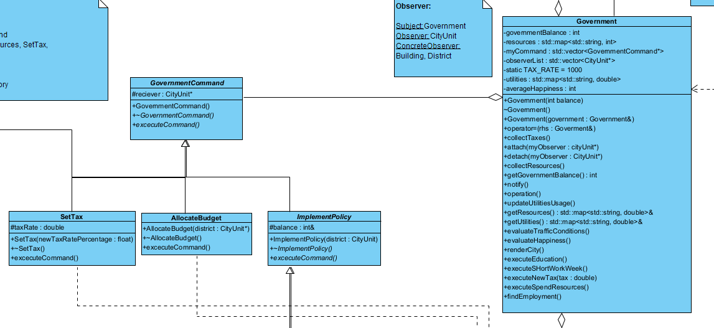

Image showing how commands are used by the government.

The government is also the subject in the observer design pattern. The Government is observed by the CityUnits. This allows the CityUnits to be notified about changes in the Government to react accordingly. The government notifies CityUnits about changes.

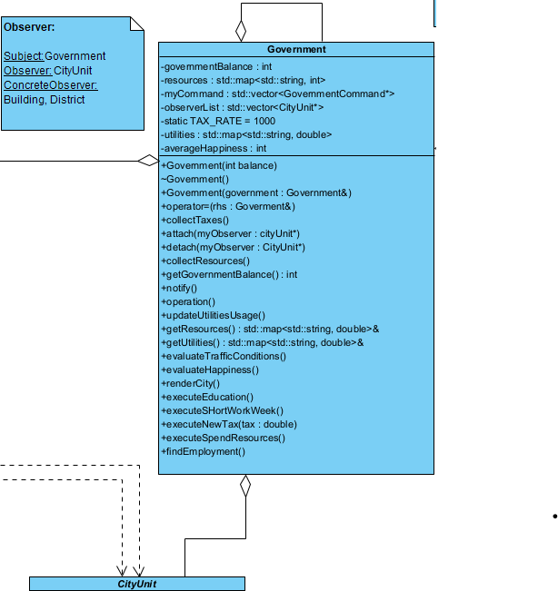

Image showing the government which is observed by the city units.

Image showing activity diagram of government notifying cityUnits

Each district has a list of contained buildings. We use the composite design pattern to treat the group of buildings uniformly. The traversing of the buildings was left for the iterator design pattern. This allows us to traverse the buildings separately without exposing the underling structure. If the method for storing buildings changed, we could implement a corresponding iterator method to handle the traversal. This could also allow us to change the traversal and storage methods at will.

Image showing the iterator and the district compostite, district inherits from cityunit.

The life of the city is the actual citizens. The citizens need to pay the taxes to keep the city running, keep the happiness up otherwise they will move cities, and do the work in the city. We used state to allow the citizens to alter their behavior based on their internal state. If the citizens are at home they shouldn’t be working(in an ideal world). If they are at work they shouldn’t be sleeping. Using state allows us to change what citizens do, how they act based on where they are. This also allows us to easily expand the system should we want to implement more state for the citizens at a later point in the project. We then used the strategy pattern to handle how the citizens travel. There are many transport methods a city can have, including roads, railway, public transport and even airplane. Using strategy here allows the transport algorithm to vary independently from the citizen doing the travelling. To display all these hidden inner working of the city we developed a web UI. We used Façade because it allows us to encapsulate the entire game simulation loop logic in a separate class, namely SimulationRunnerFacade. Façade takes care of all the required objects, such as the starter city and Government. This encapsulation makes it easier to handle the city on the UI front end. We use websockets to communicate between the frontend and backend. The WebSocketNotifier is a singleton. This makes sure there is only ever one connection between the front end and the backend. This also allows us to access the connection in any class as many objects communicate with the frontend.

Image showing how state works with the citizen

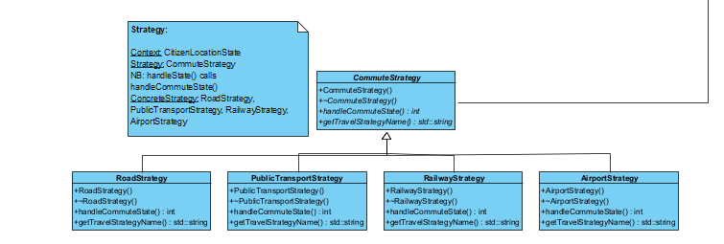

Image showing how strategy was used.

References:  
City management: <https://www.basicknowledge101.com/subjects/citymanagement.html>

City management and how to properly grow a city: <https://www.researchgate.net/publication/322152661_City_Management_Theories_Methods_and_Applications_Book_Proposal>

Components of a city: <https://archi-monarch.com/the-elements-of-a-city/>

Urban expansion: <https://www.clearpointstrategy.com/blog/types-of-urban-planning>

Healthy growth of a city: https://www.urbanet.info/planning-for-growth-how-to-manage-rapid-urbanisation/

City growth statistics: <https://www.fao.org/newsroom/story/Five-ways-to-make-cities-healthier-and-more-sustainable/en>